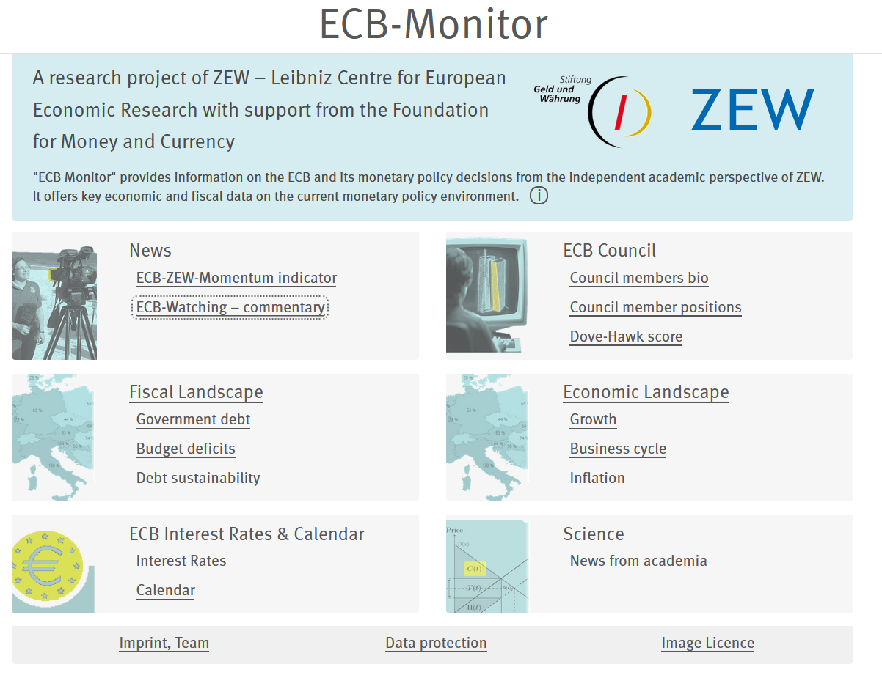
Gelb markiert neue/geänderte Texte
.. with support from the Monetary Stability Foundation

Eingangsseite

The ECB Monitor provides background information on the ECB and its monetary policy decisions from the perspective of independent academic research.

i-Box:
The ECB Monitor provides the following content:
- The quarterly ECB-ZEW-Momentum Indicator; this indicator presents a text-analytical score of the ECB Council's current monetary policy orientation, based on the most recent speeches by Council members.
- Individual scores for the monetary policy positions of all ECB Council members together with bio information.
- Current analytics from ZEW experts.
- Current data on the fiscal and economic environment, including data history for eurozone countries, with easy downloads.
- Current new research insights on monetary policy from academic work.
The ECB Monitor is intended for a broad audience, including the media, the financial industry, the public sector, and the general public, who are interested in independent background information on monetary policy.

Überschriften

News
- ECB-ZEW-Momentum Indicator (“Indicator” groß schreiben, ist Name)
- Recent expert assessments

ECB Interest Rates & Calendar
Interest rates (auf der zweiten Ebene haben wir keine Headline-Großschreibung, also „Interest rates“, nicht „Interest Rates“.
Calendar

ECB Council
Majorities ECB Council (speeches over one year)
By ECB Council individuals (full history of speeches)
Timeline ECB-ZEW-Momentum Indicator (speeches last six weeks)

Sonst sind alle Überschriften ok

Seite „News“
- ECB-ZEW-Momentum Indicator
- Recent expert assessments

Unter „Recent expert assessments“
bitte unser neues Policy Brief ablegen:
March 2026: Monetary policy stance of potential successors to Lagarde, Friedrich Heinemann and Jan Kemper, ZEW Policy Brief No. 5/2026
https://www.zew.de/fileadmin/FTP/policybrief/de/pb05-26.pdf

Seite Fiscal Landscape

Linke Spalte info-Box
Graue Zeile der sich öffnenden Info-Box: „Context and user help” („Interpretation assistance“ löschen)

The fiscal environment is important for the conduct of monetary policy. The Maastricht Treaty aimed to ensure that public debt levels remained sustainable in order to protect the ECB's effective independence. This page provides essential information on the fiscal positions of eurozone countries over time.
Using the slider, you can select a time period.
Press the play button to see how the respective variable changes over time.
Press the download button to get an Excel file containing the respective variable’s data history for all eurozone countries.

Rechte Spalte Infos zu den jeweiligen Variablen

General government gross debt in % GDP
Source: European Commission, AMECO Database, variable code: UDGG
This variable quantifies the total public debt of all government levels and social security relative to Gross Domestic Product. The data for the current and next year are forecasts provided by the European Commission.
General government balance in % GDP
Source: European Commission, AMECO Database, variable code: UBLG
This variable indicates whether the general government budget (relative to Gross Domestic Product) is in surplus (a positive number) or in deficit (a negative number). The data for the current and next year are forecasts provided by the European Commission.

General government expenditure in % GDP
Source: European Commission, AMECO Database, variable code: UUTG
This variable indicates the size of the general government in terms of total government expenditure relative to the Gross Domestic Product. The data for the current and next year are forecasts provided by the European Commission.
General government interest payments in % government expenditure
Source: European Commission, AMECO Database, variable code: UYIG/D.41
This variable shows the share of interest payments on outstanding public debt in total government expenditure. The data for the current and next year are forecasts provided by the European Commission.

Central government bond yield secondary market with residual maturity of around 10 years.
Source: Eurostat, online data code: teimf050
This variable provides information on borrowing costs for new government bonds. It shows central government bond yields on the secondary market with a residual maturity of around 10 years. Unlike the other fiscal variables which are reported on an annual basis, this variable is reported monthly.

Seite Economic Landscape
Linke Spalte info-Box
Graue Zeile der sich öffnenden Info-Box: „Context and user help“ („Interpretation assistance“ löschen)

Monetary policy decisions reflect the economic environment. Key variables that central banks consider are both the inflation rate and the growth rate. Typically, central banks will opt for a more expansionary monetary policy if inflation and economic growth are low, and a more restrictive policy if they are high.
Using the slider, you can select a time period.
Press the play button to see how the respective variable changes over time.
Press the download button to get an Excel file containing the respective variable’s data history for all eurozone countries.

Rechte Spalte Infos zu den jeweiligen Variablen
Real GDP growth in %
Source: European Commission, AMECO Database, variable code: OVGD
This variable shows the real (i.e. inflation-adjusted) annual growth rate of the Gross Domestic Product. The data for the current and next year are forecasts provided by the European Commission.

Output gap: gap between actual and potential GDP in % of potential GDP
Source: European Commission, AMECO Database, variable code: AVGDGP
This variable shows the difference between actual and the potential Gross Domestic Product. A positive number indicates a strong economic situation, as the actual economic activity is above the level that can be sustained in the long term. Conversely, a negative number indicates a weak economic situation, as economic activity is below what is possible given the available production factors. The data for the current and next year are forecasts provided by the European Commission.

Inflation (Harmonised Index of Consumer Prices) in % relative to same month of previous year
Source: Eurostat, Variablen-Code: prc_hicp_manr, CP00 - All-items HICP
This variable shows the inflation rate according to the “Harmonised Index of Consumer Prices” (HICP). The HICP inflation is the most prominent variable considered by the ECB Council since the ECB’s primary objective – “inflation of 2% over the medium term” – refers to the HICP. The data for the current and next year are forecasts provided by the European Commission.

----------------------------

Seite ECB Council stance

Großschreibung “ECB Council Stance“ (nicht „stance“; alle anderen Seitentitel sind auch durchgängig groß geschrieben)

Folgende drei Unterpunkte verwenden (durchgängig), auch auf Eingangsseite EZB-Monitor
Majorities ECB Council (speeches over one year)
By ECB Council individuals (full history of speeches)
Timeline ECB-ZEW-Momentum Indicator (speeches last six weeks)

By country – rename as „Majorities ECB Council (speeches over one year)”
“ECB Council Dove-Hawk positions - countries and median” ersetzen durch:
“ECB Council dove-hawk positions one year – individuals and median”
Linke Spalte info-Box
Graue Zeile der sich öffnenden Info-Box: „Context and user help“ („Interpretation assistance“ löschen)

Inhalt Info-Box:
The graph shows the hawkishness score for each member of the ECB Council, alongside the median score.
The median score divides individuals into two equal groups, one more hawkish and one less.
Thus, the graph conveys an impression of both the majority position and the variance of views in the ECB Council for each year.

Textbox unter Hawkometer:
Needle shows the median score in the Council: 0.26
The circles show the scores of the individual members of the ECB Council.
Hover over circles to see the individual representative of the country.
For the current year, scores are calculated based on speeches given over the last 12 months. For previous years, they are based on speeches given in the respective calendar year.
Values are missing for individuals for whom no speeches exist.

By geography – rename as „By ECB Council individuals (full history of speeches)”

“ECB Council - geography” ersetzen durch:
“ECB Council dove-hawk positions – individuals’ total history since appointment”

Linke Spalte info-Box
Graue Zeile der sich öffnenden Info-Box: „Context and user help“ („Interpretation assistance“ löschen)

Inhalt Info-Box:
The map shows the hawkishness score of each ECB Council member.
It also provides biographical information on each member.
The hawkishness scores on the map are calculated using the full history of the individuals’ speeches since their appointment to the ECB Council. The hawkishness scores for each speaker are the average over the hawkishness scores of all speeches held by this person while being a member of the ECB Council.
Due to this method of calculation, differences in scores are influenced by the monetary policy environment during an individual’s time on the Council.
Hover over the map to view the names and biographical information of the individual members of the ECB Council.

Timeline – rename as “Timeline ECB-ZEW-Momentum Indicator (speeches last six weeks)”

“ECB Council - effective Dove-Hawk score timeline”

Ersetzen durch
“ECB-ZEW-Momentum Indicator and ECB deposit rate over time”

Linke Spalte info-Box
Graue Zeile der sich öffnenden Info-Box: „Context and user help“ („Interpretation assistance“ löschen)

Inhalt Info-Box:
The graph shows the ECB-ZEW Momentum Indicator alongside the ECB deposit rate.
The deposit rate is the key rate among central bank rates, as determined by the ECB.
The ECB-ZEW Momentum Indicator provides an average hawkishness score based on speeches given by all ECB Council members over the last six weeks.
The indicator thus provides current information on the monetary policy stance revealed in the decision-makers' speeches.
For more information on the methodology behind the ECB-ZEW-Momentum Indicator, please refer to the Method Paper.

Graph:
“Opinion score” ersetzen durch “ECB-ZEW Momentum Indicator“ – sowohl auf der vertikalen Achse als auch in der Legende, die bei mouse-over erscheint.

Eintrag rechts:
„Rate settings follows Dovish-Hawkish score. Plausible, but causal relation cannot be proved.” Ersetzen durch:
“ECB-ZEW Momentum Indicator and ECB deposit rate over time”

Seite Science

News from Academia
Proxy – Eintrag ersetzen durch den folgenden:
Heinemann, Friedrich und Jan Kemper (2026), ECB Council Members’ Objectives and Public Debt at Home – Evidence From an AI-Based Textual Analysis, ZEW Discussion Paper Nr. 26-005, Mannheim.

This ZEW discussion paper studies the changing attention that ECB Governing Council members pay to different policy objectives.
The study analyzes more than 4,600 speeches given between the establishment of the ECB and the summer of 2024. Alongside the primary objective of price stability, it considers the following potential secondary objectives: financial stability, stability of the government bond market, sustainable public debt, climate protection and distribution. On the methodological side, the analysis takes advantage of LLMs to identify the speeches’ coverage of each of these objectives and the associated support.
The results suggest that objectives have become more diverse in recent years. An increase in the public debt-to-GDP ratio in a governor’s home country is associated with a shift in focus away from the primary objective and towards a growing coverage and support for secondary objectives. This general pattern is particularly robust for the distribution objective. These results can only be partly explained by governor selection. Therefore, in their communication, individual governors indicate shifts in their objective function in response to changes in the fiscal situation of their home country.

https://www.zew.de/publikationen/ecb-council-members-objectives-and-public-debt-at-home-evidence-from-an-ai-based-textual-analysis

